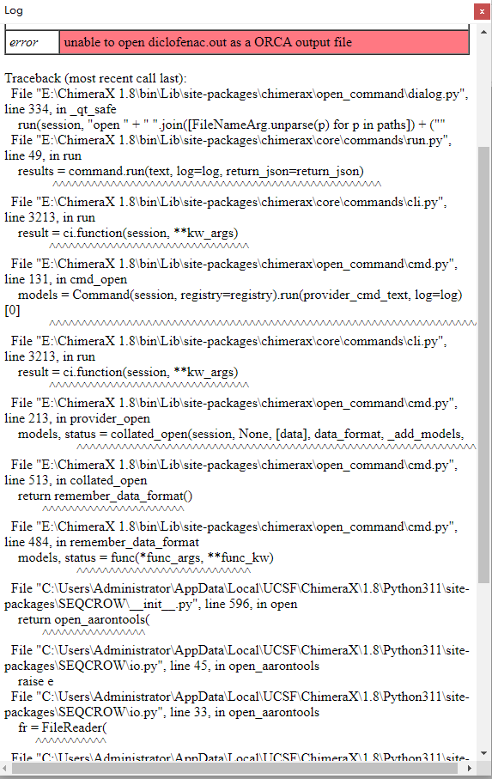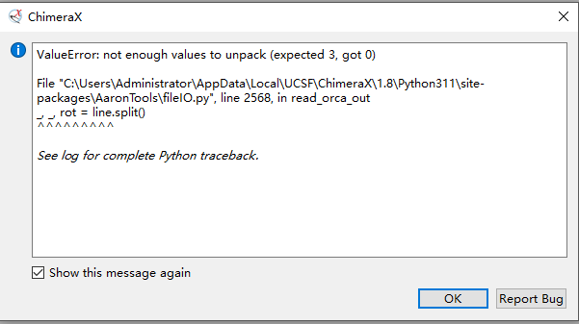
Traceback (most recent call last):
File "E:\ChimeraX 1.8\bin\Lib\site-packages\chimerax\open_command\dialog.py", line 334, in _qt_safe
run(session, "open " + " ".join([FileNameArg.unparse(p) for p in paths]) + (""
File "E:\ChimeraX 1.8\bin\Lib\site-packages\chimerax\core\commands\run.py", line 49, in run
results = command.run(text, log=log, return_json=return_json)
^^^^^^^^^^^^^^^^^^^^^^^^^^^^^^^^^^^^^^^^^^^^^^^^^^^
File "E:\ChimeraX 1.8\bin\Lib\site-packages\chimerax\core\commands\cli.py", line 3213, in run
result = ci.function(session, **kw_args)
^^^^^^^^^^^^^^^^^^^^^^^^^^^^^^^
File "E:\ChimeraX 1.8\bin\Lib\site-packages\chimerax\open_command\cmd.py", line 131, in cmd_open
models = Command(session, registry=registry).run(provider_cmd_text, log=log)[0]
^^^^^^^^^^^^^^^^^^^^^^^^^^^^^^^^^^^^^^^^^^^^^^^^^^^^^^^^^^^^^^^^^^^
File "E:\ChimeraX 1.8\bin\Lib\site-packages\chimerax\core\commands\cli.py", line 3213, in run
result = ci.function(session, **kw_args)
^^^^^^^^^^^^^^^^^^^^^^^^^^^^^^^
File "E:\ChimeraX 1.8\bin\Lib\site-packages\chimerax\open_command\cmd.py", line 213, in provider_open
models, status = collated_open(session, None, [data], data_format, _add_models,
^^^^^^^^^^^^^^^^^^^^^^^^^^^^^^^^^^^^^^^^^^^^^^^^^^^^^^^^^^^^^^
File "E:\ChimeraX 1.8\bin\Lib\site-packages\chimerax\open_command\cmd.py", line 513, in collated_open
return remember_data_format()
^^^^^^^^^^^^^^^^^^^^^^
File "E:\ChimeraX 1.8\bin\Lib\site-packages\chimerax\open_command\cmd.py", line 484, in remember_data_format
models, status = func(*func_args, **func_kw)
^^^^^^^^^^^^^^^^^^^^^^^^^^^
File "C:\Users\Administrator\AppData\Local\UCSF\ChimeraX\1.8\Python311\site-packages\SEQCROW\__init__.py", line 596, in open
return open_aarontools(
^^^^^^^^^^^^^^^^
File "C:\Users\Administrator\AppData\Local\UCSF\ChimeraX\1.8\Python311\site-packages\SEQCROW\io.py", line 45, in open_aarontools
raise e
File "C:\Users\Administrator\AppData\Local\UCSF\ChimeraX\1.8\Python311\site-packages\SEQCROW\io.py", line 33, in open_aarontools
fr = FileReader(
^^^^^^^^^^^
File "C:\Users\Administrator\AppData\Local\UCSF\ChimeraX\1.8\Python311\site-packages\AaronTools\fileIO.py", line 1555, in __init__
self.read_orca_out(f, get_all, just_geom)
File "C:\Users\Administrator\AppData\Local\UCSF\ChimeraX\1.8\Python311\site-packages\AaronTools\fileIO.py", line 2568, in read_orca_out
_, _, rot = line.split()
^^^^^^^^^
ValueError: not enough values to unpack (expected 3, got 0)
ValueError: not enough values to unpack (expected 3, got 0)
File "C:\Users\Administrator\AppData\Local\UCSF\ChimeraX\1.8\Python311\site-packages\AaronTools\fileIO.py", line 2568, in read_orca_out
_, _, rot = line.split()
^^^^^^^^^
See log for complete Python traceback.

